

DEPARTMENT OF AI AND DS

**PHOTO GALLERY**

**A Front-End UI UX Project**

**By**

CLASS: 3BTCS AIML A

Aliviya Joby-2462029

Femi K E-2462069

Devananda Vaniyan Surendran-2462063

**Instructor** : Dhiraj Alate

**Date**: 26TH September, 2025

# ABSTRACT

This project presents a responsive photo gallery website built with HTML, CSS, Bootstrap, and jQuery. It features an adaptive grid layout, hover animations, and modal popups for enlarged viewing. Designed with simplicity and usability in mind, the gallery offers an engaging visual experience suitable for portfolios, travel showcases, or personal projects.

# OBJECTIVES

• To design a clean, responsive, and user-friendly photo gallery.

• To demonstrate Bootstrap grid system and modal integration.

• To implement hover and click-based interactivity for images.

• To create a scalable layout that works across devices.

# SCOPE

**Inclusions**

* Responsive image grid using Bootstrap.
* Modal popup to enlarge images.
* Hover effects for better interactivity.
* Lightweight and easy-to-maintain code.

**Exclusions**

* Image upload or backend storage.
* Advanced filtering/sorting of images.
* User accounts or personalization.
* Cloud storage integration (only static images used).

# TOOLS AND TECHNOLOGY

• **HTML5** – Page structure.

• **CSS3** – Styling, hover effects, and transitions.

• **Bootstrap 5.3** – Responsive grid and modal.

• **JavaScript & jQuery** – Event handling and interactivity.

• **Picsum Photos API** – Sample placeholder images.

# HTML STRUCTURE OVERVIEW

• <div class="container"> – Holds the gallery.

• <div class="row g-3"> – Bootstrap grid layout for images.

• <img> – Each gallery image wrapped in responsive columns.

• <div class="modal"> – Bootstrap modal for enlarged view.

• <script> – jQuery to handle click events and modal display.

# CSS STYLING STRATEGY

• Light background (#f8f9fa) for a clean layout.

• .gallery-img hover effect with smooth scaling.

• Rounded corners for modern UI.

• Responsive sizing with Bootstrap img-fluid.

• Modal image styled for full-width display.

# KEY FEATURES

| **Feature** | **Description** |
| --- | --- |
| Responsive Image Grid | Images arranged in rows and columns using Bootstrap grid. |
| Hover Animation | Subtle scaling effect for interactivity. |
| Modal Popup | Enlarges image in a clean overlay for better viewing. |
| Cross-device Compatibility | Works smoothly on mobile, tablet, and desktop. |

# CHALLENGES FACED AND SOLUTIONS

• **Maintaining aspect ratio** → Used img-fluid for responsiveness.

• **Image clarity in modal** → Modal image set to width: 100%.

• **Managing clicks** → jQuery used to dynamically update modal source.

# OUTCOME

• A fully functional, responsive, and interactive photo gallery.

• Improved user experience through hover and modal features.

• Clean design suitable for portfolios, travel galleries, or events.

• Provides a base for expanding into a dynamic, real-world gallery system.

# FUTURE ENHANCEMENTS

• Add image categories and filtering.

• Include slideshow and navigation arrows in modal.

• Implement image upload and backend storage.

• Add captions and metadata for each image.

• Use lazy loading for better performance.

# SAMPLE CODE

2 PAGES OF HTML CODE(SAMPLE)

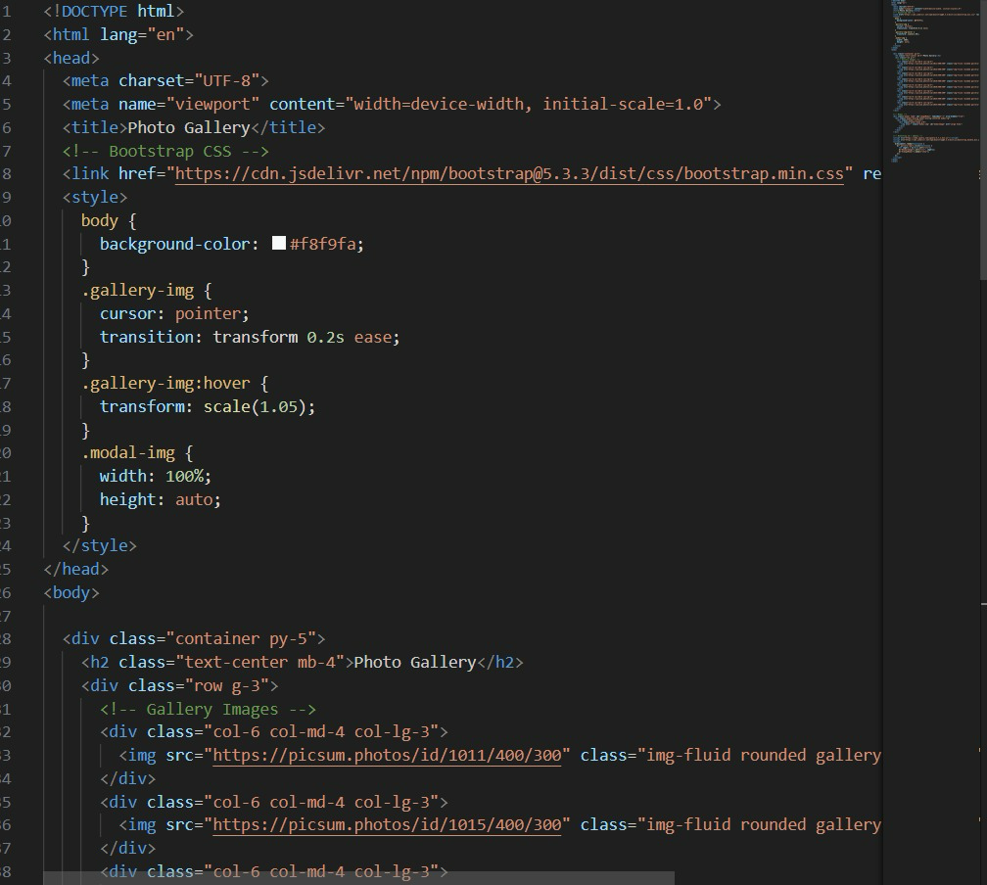  
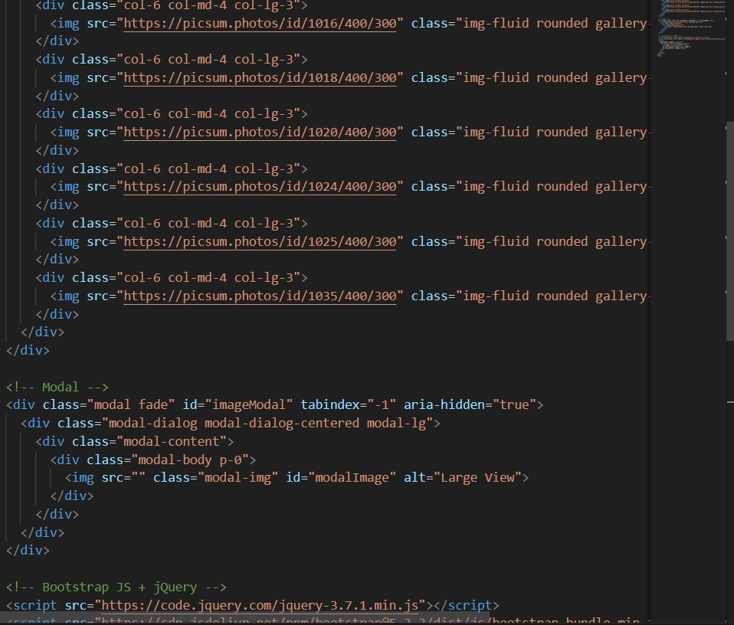

# OUTPUT SCREEN

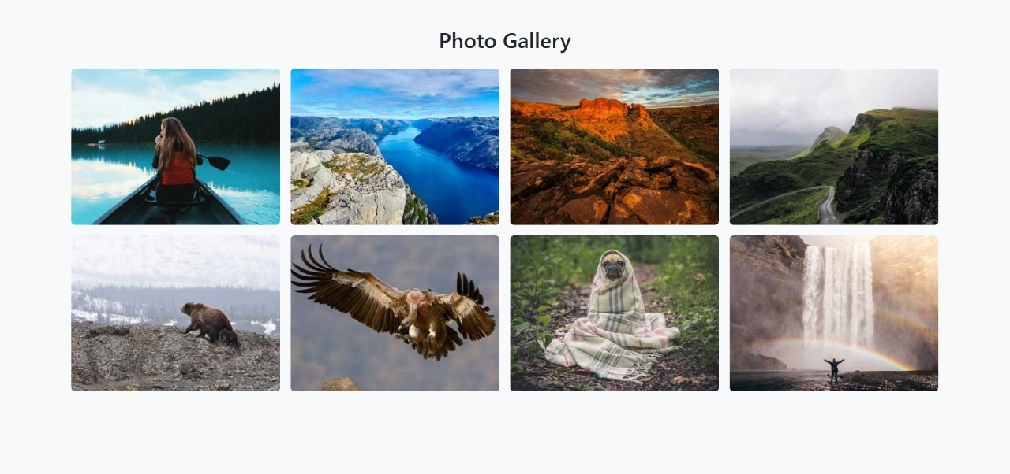

# CONCLUSION

The photo gallery project successfully demonstrates responsive web design and interactive functionality using front-end technologies. By combining Bootstrap’s grid system with jQuery-driven modals, the website delivers both style and usability. This implementation provides a strong foundation for future enhancements such as filtering, captions, and dynamic image management, extending real-world applicability.

# REFERENCES

* L&T LMS:<https://learn.lntedutech.com/Landing/MyCourse>
* MDN Web Docs – HTML & CSS: https://developer.mozilla.org/
* Google Fonts: https://fonts.google.com/